

“Redefining how you shop”

For the partial fulfillment of the requirements for the completion of the course - Software Engineering Practice (CS307)

SOFTWARE DESIGN DOCUMENT (SDD)

123cs0004 - N. Pranav

123cs0011 - Ankit Kumar

123cs0052 - M. Vighnesh

123cs0058 - G. Vardhan

## **Introduction to Design (Gathr)**

Gathr is a local-first e-commerce platform that connects customers with nearby shops and vendors. The design emphasizes intuitive browsing, simple vendor management, and smooth order processing through delivery partners. It is built to be scalable, supporting multiple vendors and customers at the same time while maintaining a seamless user experience. Gathr also fosters local economies by giving small businesses a digital storefront. The platform is designed to adapt and grow with evolving community needs and shopping behaviors.

Design Requirements Categories

Functional Requirements

Shop & product browsing: Display a list of local shops and their individual product listings with categories, search, filters, and sorting options.

User accounts: Registration, login/logout, profile management, order history.

Shopping cart & checkout: Add/remove products, apply discounts/coupons, multiple payment methods, guest checkout option.

Order management: Customers place orders, vendors accept/decline orders, order status updates visible to customers.

Delivery integration: Assign delivery personnel, tracking of delivery status, confirmation on receipt.

Reviews and ratings for shops and products.

Notifications: Real-time alerts for order confirmations, delivery updates, and promotions.

Vendor tools: Shop management dashboard for inventory, orders, promotions.

Support: Contact forms, FAQs, and customer service access.

Non-functional Requirements:

*Product Requirements:*

* Performance: Fast response times for browsing, search, and checkout (under 3 seconds).
* Scalability: Handle increasing users, shops, products, and orders without slowdown.
* Security: Encryption for data in transit and at rest, secure authentication, PCI-compliant payment handling.
* Usability & Accessibility: Responsive design and very easy to use to support diverse customers.
* Maintainability: Modular architecture with clear documentation, enabling easy updates and debugging by ensuring very low coupling.

*Organizational Requirements:*

* Compliance: Adherence to local privacy, and consumer protection laws.
* Security Policies: Roles and permissions assigned to restrict access within the organization.
* Support & Training: Adequate staff training for handling the platform, order management.

*External Requirements*

* Legal & Regulatory: Ensuring the platform complies with e-commerce regulations, tax rules, and copyright laws governing online sales.
* Interoperability: Smooth functioning across different browsers, devices, and third-party platforms.

Actors for Gathr System (Use Case)

Customer: Browses shops and products, places orders, tracks deliveries, and provides reviews.

Shopkeeper (Vendor): Manages their shop profile, product listings, order acceptance, and updates order status.

Delivery Person: Accepts delivery assignments, updates delivery status, and confirms order delivery to customers.

Admin: Oversees platform operations, manages users and shops, handles disputes, and oversees payments and reports.

### **Different Types of Classes and Attributes**

### **User Attributes:**

* userId
* firstName
* lastName
* email
* role (customer, merchant)
* clerkId (external auth ID)
* addresses (list of Address)
* orders (list of Order)

### **Shop Attributes:**

* shopId
* owner (User)
* shopName
* location (Geopoint)
* address
* contactNumber
* rating
* category
* imageUrl

### **Item Attributes:**

* itemId
* shop (Shop)
* name
* description
* price
* quantityInStock
* category
* imageUrls (list)
* rating

### **Cart Attributes:**

* cartId
* user (User)
* items (list of CartItem)
* lastUpdated

### **CartItem Attributes:**

* item (Item)
* quantity

### **Order Attributes:**

* orderId
* customer (User)
* shop (Shop)
* orderItems (list of Item or OrderItem)
* shippingAddress (Address)
* orderDate
* totalCost
* status (Ordered, Accepted, Shipped, Delivered, Cancelled)
* payment (Payment)

### **Address Attributes:**

* addressId
* user (User)
* title (e.g., Home, Work)
* fullAddress
* location (Geopoint)
* mobileNumber

### **Payment Attributes:**

* paymentId
* order (Order)
* amount
* paymentMethod (e.g., UPI, Card)
* status (Pending, Successful, Failed)
* transactionId
* paymentDate

User Interaction with the System

User interaction with the Gathr system involves several typical flows and patterns aimed at making the shopping experience intuitive, efficient, and engaging for both customers and vendors. Here’s an overview of how users interact with the system:

* Browsing and Searching Shops and Products:  
  Users start by browsing local shops or using search and filter options to find specific products. The interface provides clear categories, product images, detailed descriptions, and ratings to aid decision-making.
* Account Management:  
  Users can create accounts or log in to manage their profiles, addresses, and payment methods securely. Account management also includes viewing order history and tracking current orders.
* Adding to Cart and Checkout:  
  Customers add items to their shopping cart, update quantities, and remove unwanted items. The checkout process collects shipping information and payment details in a streamlined flow with options for various payment methods.
* Order Management:  
  After placing an order, customers can track its status—from order confirmation to delivery. Vendors view and manage incoming orders, updating statuses such as acceptance, shipping, and completion.
* Delivery Coordination:  
  Delivery personnel interact with assigned orders, update delivery progress in real-time, and confirm successful deliveries to customers.
* Communication Channels:  
  The system facilitates communication between customers and vendors through messaging or queries related to products or orders. Notifications keep users informed about order changes, promotions, and system updates.
* Reviews and Feedback:  
  Customers provide ratings and reviews for products and shops, contributing to the community and aiding other users in making informed choices.
* Responsive and Accessible Design:  
  Users experience seamless interaction across desktop and mobile devices, with interface elements optimized for quick navigation, easy input, and accessibility compliance.

## **Types of Reports to be Generated (Use Case)**

The system generates reports for business and administrative purposes, helping vendors and administrators monitor performance.

* **Sales Reports:** Summarizes total sales and revenue over different periods (daily, weekly, monthly) to track business performance.
* **Inventory Reports:** Shows current stock levels for all products and highlights items that are low in stock for reordering.
* **Order Reports:** Provides a history of all orders with statuses like 'Accepted', 'Delivered', and 'Cancelled', helping analyze order fulfillment patterns.
* **Product Performance Reports:** Lists best-selling and least-selling items to help optimize the product catalog.
* **System-Wide Revenue Reports:** Shows total platform revenue, commissions, and payment success rates.
* **User Growth Reports:** Tracks new registrations for customers, shopkeepers, and delivery personnel over time.
* **Vendor Performance Reports:** Compares shops based on sales volume, customer ratings, and order fulfillment rates.
* **Delivery Efficiency Reports:** Analyzes delivery performance, including average delivery time, deliveries per person, and successful delivery rates.

**Use Case Diagram**

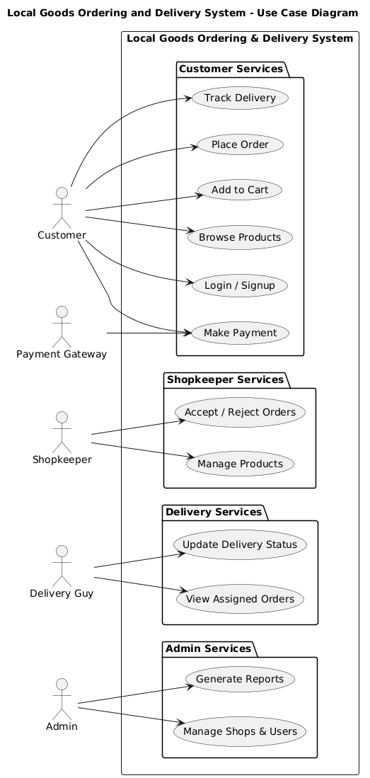

**Class Diagram**

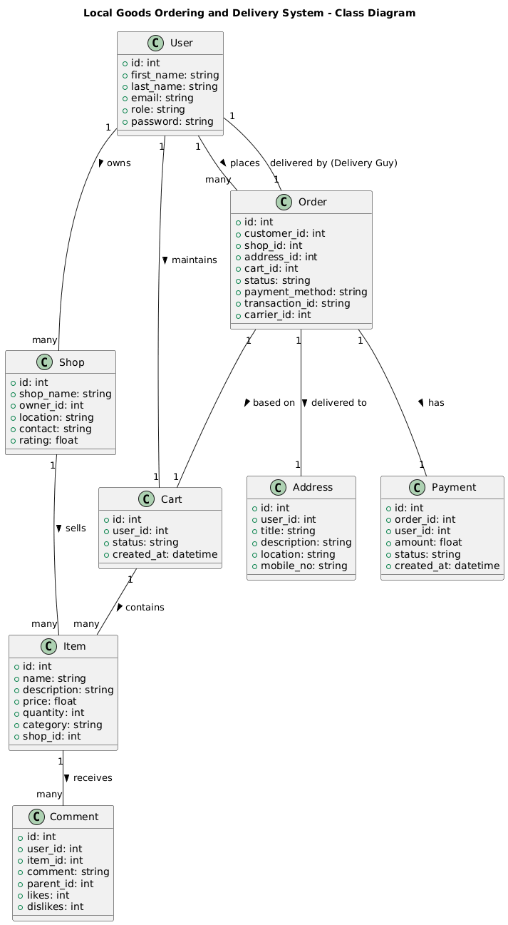

Activity Diagram

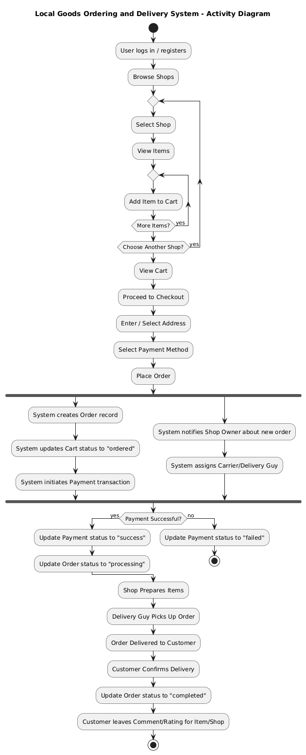

Object Diagram

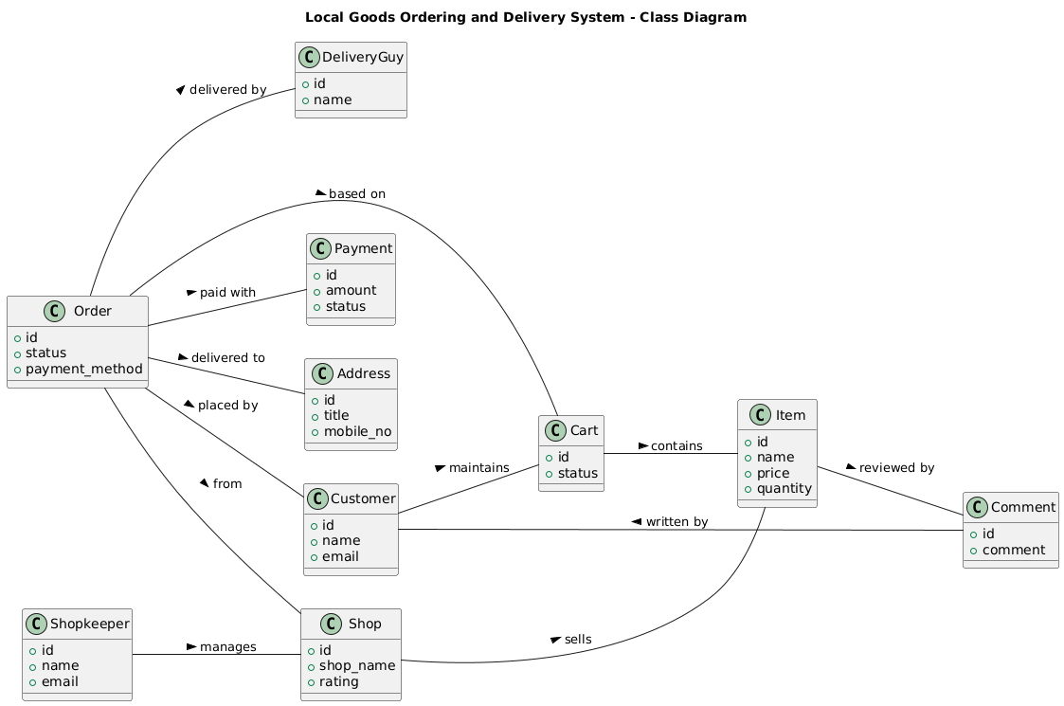

Data Flow Diagram

